DISTRICT 2 BUSINESS MEETING

When: | Wednesday, July 19, 2023
Time: | 6:30-8:00 p.m.
Where: | St. Paul’s United Church of Christ, in the Adult Lounge West Room, 5508 Telegraph Road, St. Louis, MO 63129. Enter parking lot at stoplight and park in rear near the small play area. A sign will be on the door and go up steps; meeting room will be directly ahead. There is a wheelchair lift available at another entrance; call Mary Kay if that is needed.
Zoom: | Meeting ID: 865 8553 6855 Passcode: 072722

Guest Speaker: Sue Kieffer, Missouri Area Delegate

All members are welcome. We hope to have one representative from each group in District 2 attend in person or via Zoom.
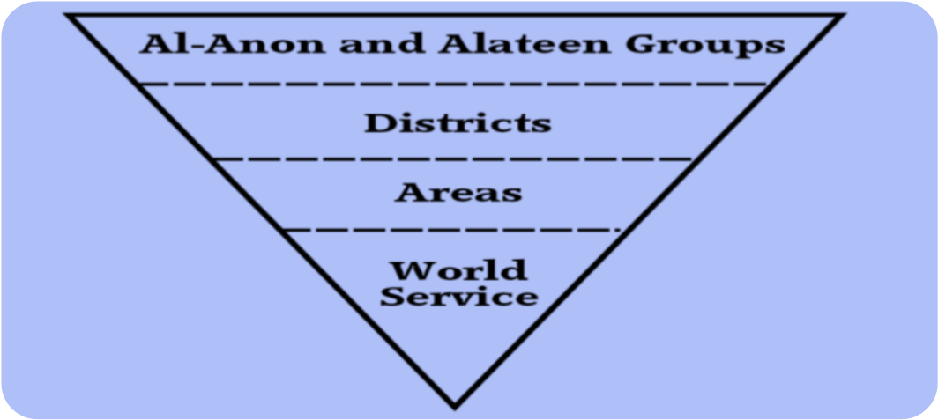

2023 Meetings: July19, September 20, and November 15

Questions: Contact Mary Kay H. at 314-803-5549

