mostateconvention.org

Unified
in
Recovery and Fellowship
July 29th—31st 2022

Friday
With AFG Participation

Erin G.— Peculiar, MO - AFG
Ashley O.— Des Moines, IA

Saturday
Doug R. - Tujunga, CA
Michael C.— Pineville, MO - AFG
Carla R. - Tujunga, CA

Sunday
Doug O.— Des Moines, IA

CAPITOL PLAZA HOTEL
415 W MCCARTY ST
JEFFERSON CITY,MO
800-338-8088
USE CODE MISSOURI STATE CONVENTION
ROOM RATE-$97 + TAX PER NIGHT

register online at MOSTATECONVENTION.ORG or complete this form and mail to
MOSC Registration ~ PO Box 407 ~ Columbia MO 65205
Complete one form per registration. Make checks/money orders payable to MOSC

Email Name Address City State Zip

[_] Early Registration $20 Before June 30th
[_] Registration $25
July 1st and after

Phone ( )
AA [_] AFG [_]
[_] Saturday Night Banquet $31

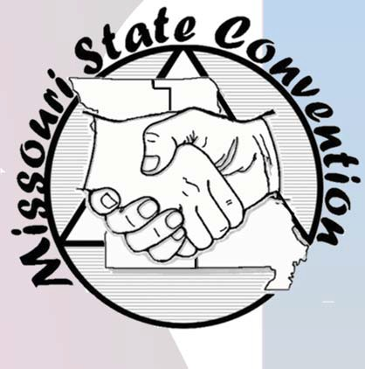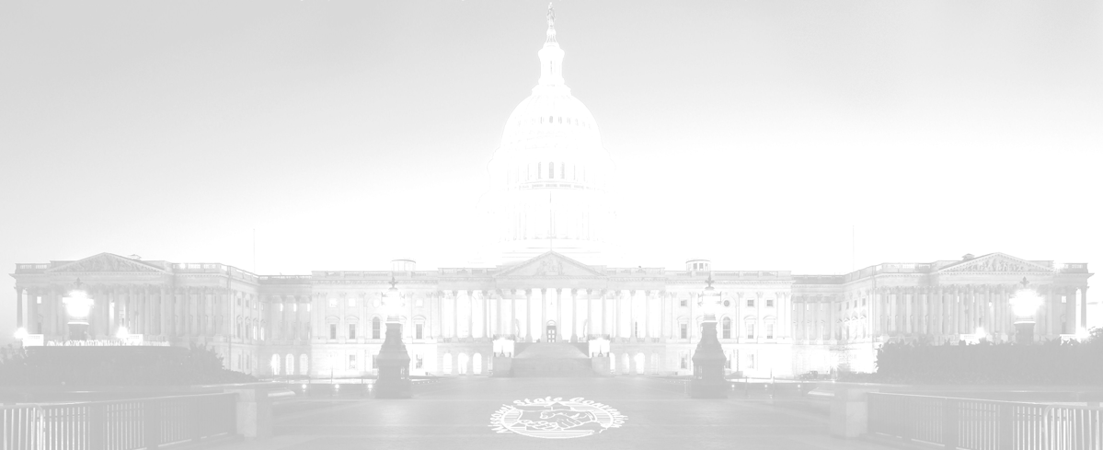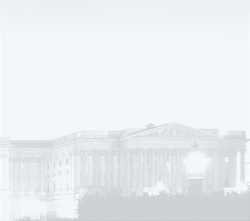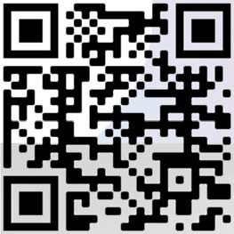Name on badge if other than ﬁrst name last initial
Hotel Restaurant
Discounted price
if included with registration
[_] Friday Evening Buﬀet $16.50
[_] Saturday Breakfast
[_] Saturday Lunch
[_] Sunday Breakfast
$10.50
$11.50

$10.50

I am staying at the hotel for nights
I would like to volunteer to help at the convention |_|
[_] or Vegetarian Option
[_] Friday Night Ice Cream $ 5 [_] Saturday Night Ice Cream $ 5 [_] Additional Contribution $

Total included $

